BUS BOOKING SYSTEM

By: -

Omprakash Choudhary(14BCE0240)

Vishal Kumar Vasnani(14BCE0079)

Aakash Shaw(14BCE0107)

Abstract:

This mini project is used for booking online bus tickets. Here in this project we have many buses (AC, Non AC, etc.) available and our source is default (Vellore) since we have only buses from this place whereas in destination many different places are listed. A single passenger can book a maximum of 10 seats. Next by choosing the Date of Journey and on clicking the search option it will show the number of buses and its details available for your destination. ‘Search Buses’ option goes into the database to look for the corresponding buses available and then the user selects the bus he needs and by clicking on book now option his ticket will be booked. The application uses a variety of tools and languages that perform in a harmony to provide perfect results.

Front-end and Back-end Tools:

* **Front-end**:

In front-end we have used ASP.NET and C# as the main scripting languages with html5 to design the website.

* **Back-end**:

The Back-end is designed in MS SQL in the .NET framework using customized Queries given by us for the optimum output.

* The entire Front-end and Back-end is connected using SqlConnections in Microsoft Visual Studio (2015). The SqlConnections help the front-end extract data from database present in a remote server and display it in the GUI.

ER DIAGRAM:

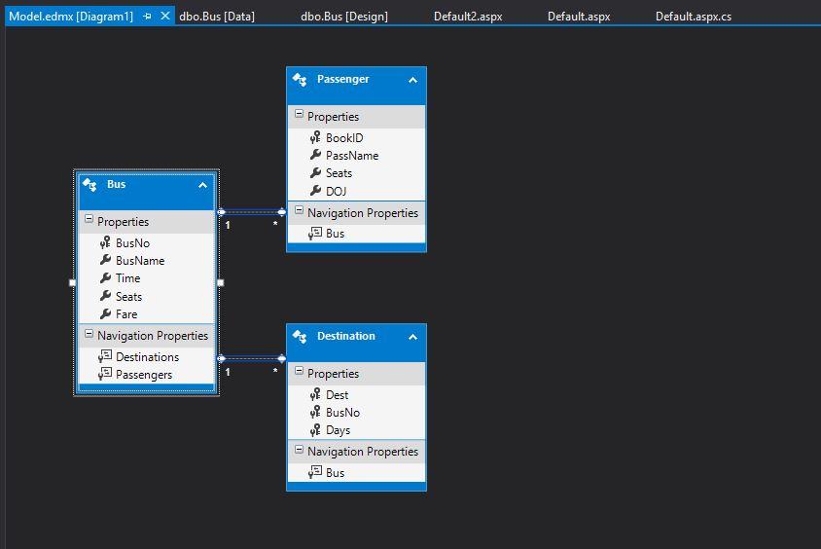

ER to Relational Mapping:

**Destination**:

|  |  |  |
| --- | --- | --- |
| Dest | BusNo | Days |

FK REFERENCES

Bus(BusNo)

**Bus**:

|  |  |  |  |
| --- | --- | --- | --- |
| BusNo | BusName | Seats | Fare |

**Passenger**:

|  |  |  |  |  |
| --- | --- | --- | --- | --- |
| BookID | BusNo | PassName | Seats | DOJ |

IDENTITY

BUS 1 TAKES N PASSENGER

BUS 1 GOES TO N DESTINATION

TABLE CREATION:

**BUS:**

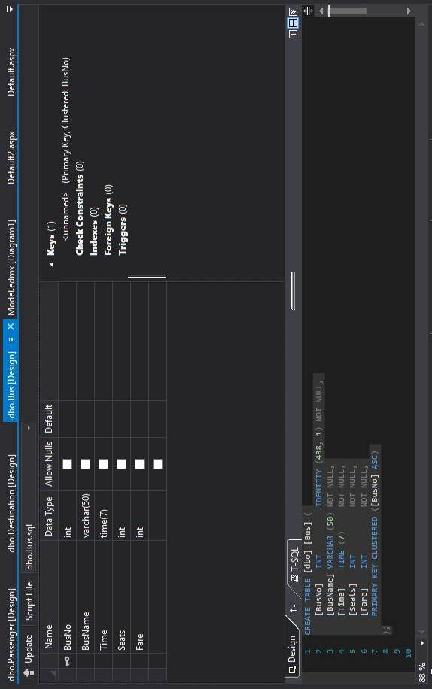

**DESTINATION:**

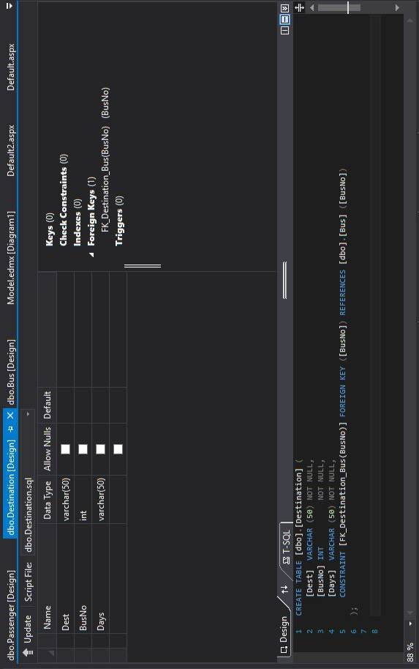

**PASSENGER:**

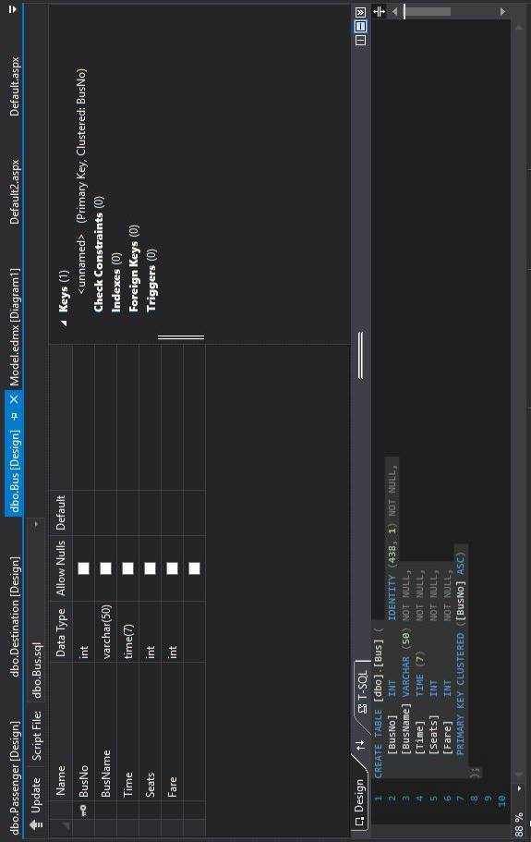

Table data:

Bus:

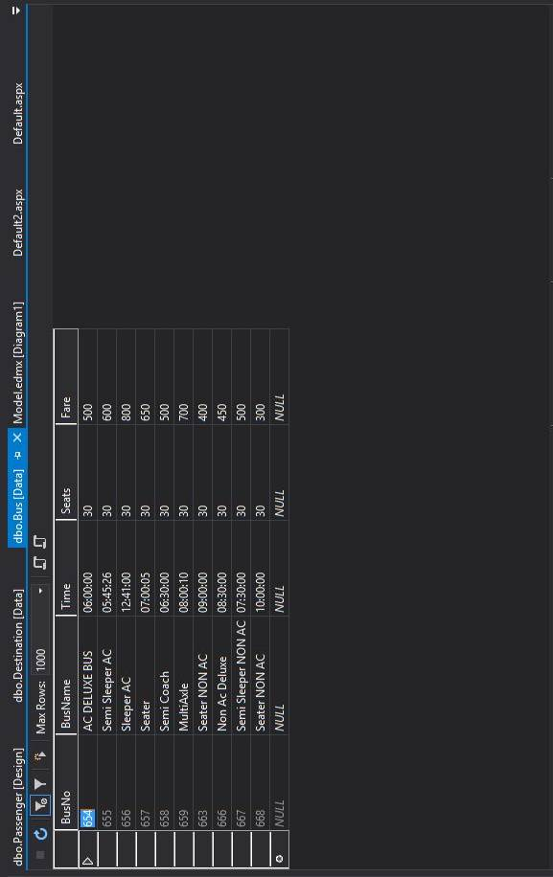

Destination:

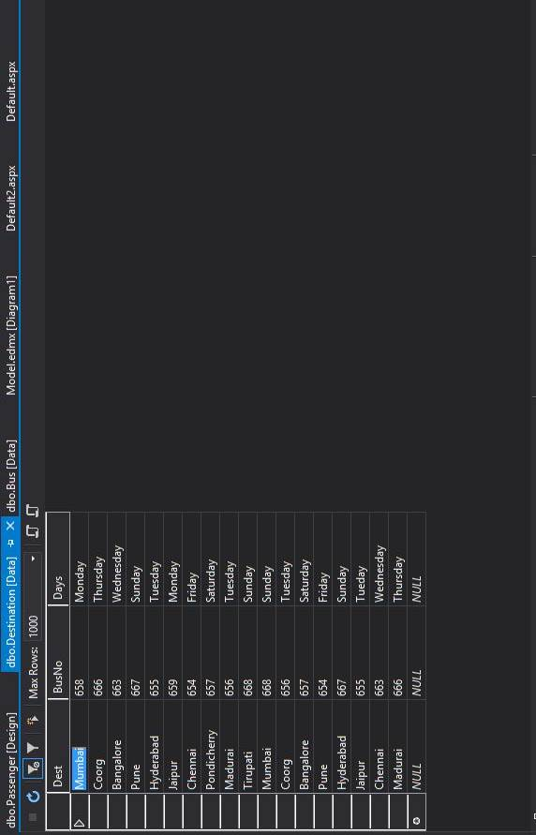

Relationship Between Tables:

**Destination Table**: Destination table consists of columns Dest, BusNo and Days. Dest corresponds to destination; BusNo is Foreign Key that references to Bus table’s BusNo column and validates the data from there. Days represents the day on which the corresponding bus will transport to the corresponding destination.

**Bus Table**: Bus table is the table that stores the details of the bus. It consists of columns BusNo, BusName, Seats and Fare.

BusNo is the primary key of the table that determines the unique Bus details from the table. This is also the foreign key reference for BusNo in Destination table.

**Passenger Table**: Passenger comes in action when all the details in the form are filled and the customer is booking the bus. It stores the information of the booking into columns BookID, CustomerName, Seats and DOJ. BookID is the primary key in the table which uniquely identifies each and every booking.

GUI:

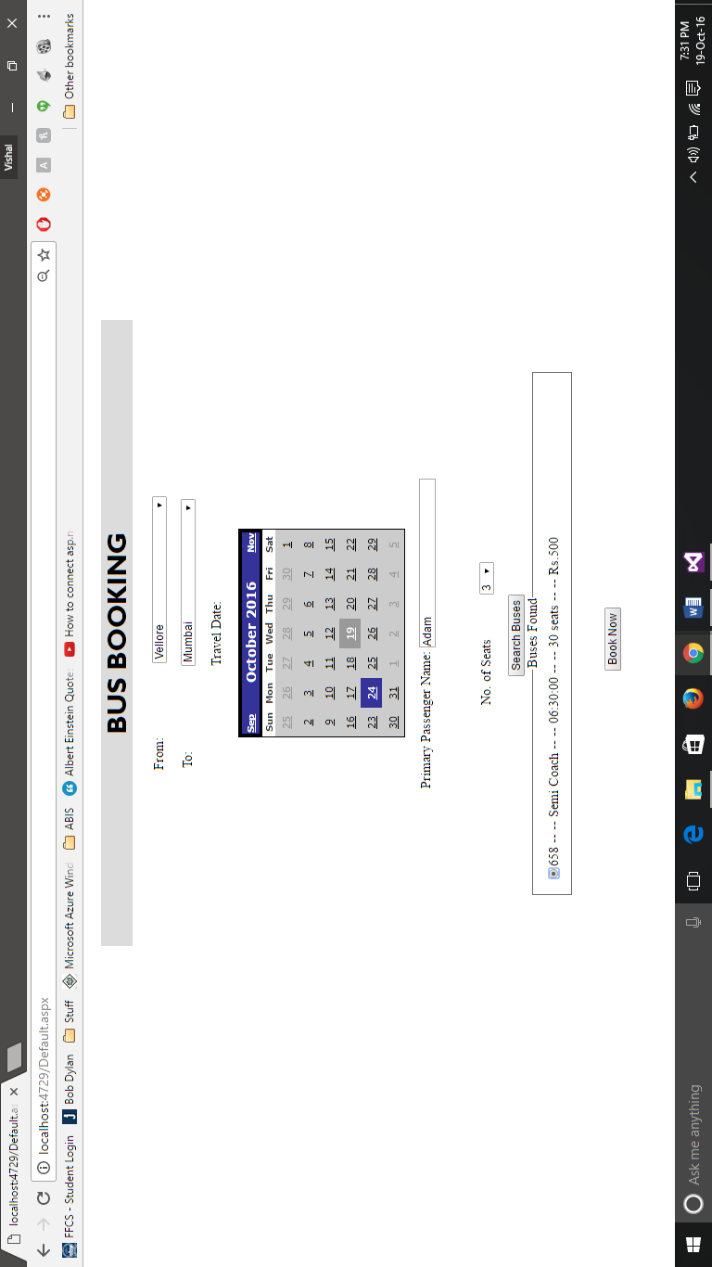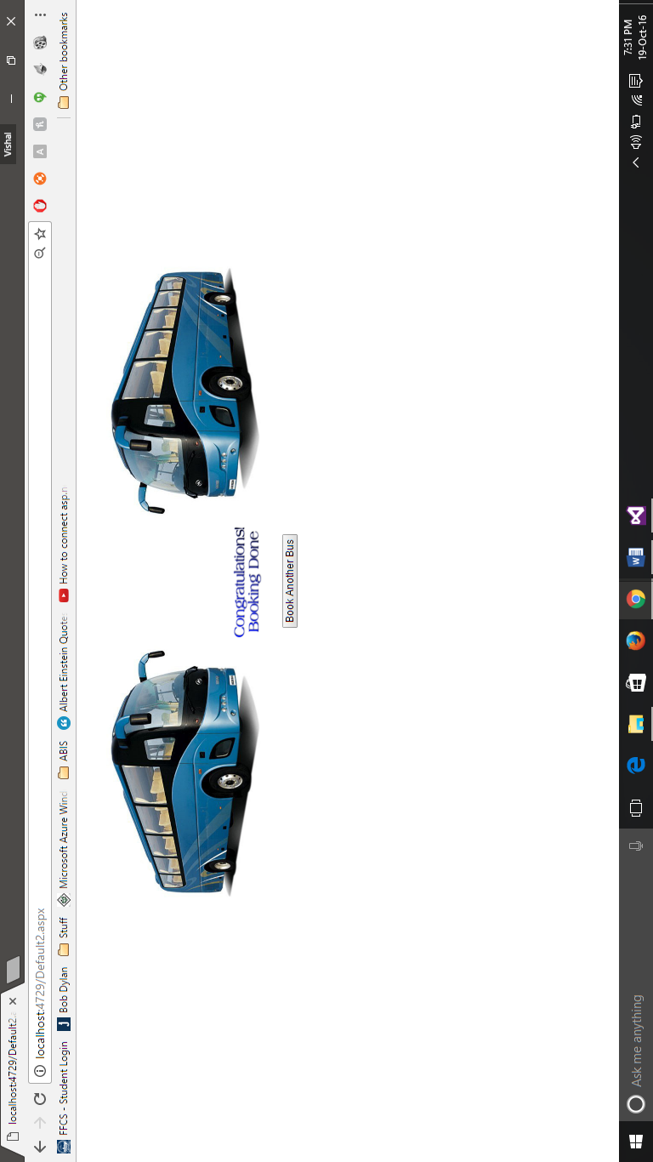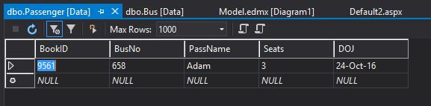

Description:

User selects the destination from the dropdown list. He selects a date from the calendar, enters his name in passenger field, selects number of seats and clicks the ‘Search Buses’ which outputs the corresponding buses from the database. He then selects a bus and click on the ‘Book Now’ button. He is then redirected to a confirmation page and his details are stored in the Passenger Table. Also there is a button ‘Book Another Bus’ on the confirmation page that lets the user to book more tickets.